Newton College: House Captains
By: Marco Hernandez Martinez

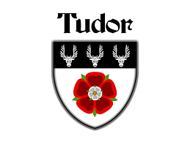

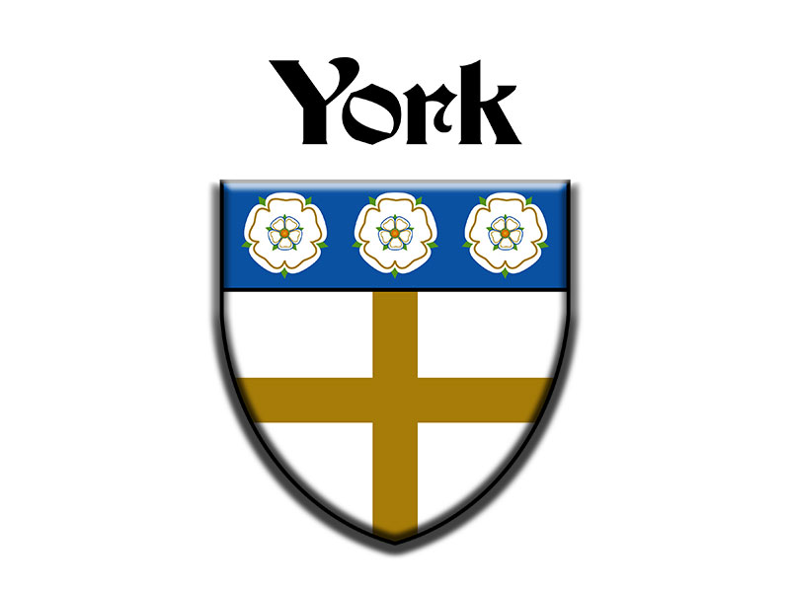

With a new school year underway, the announcement of the House Captains has already started to build excitement across the school community. Representing Lancaster, Tudor, Windsor, and York, this year’s selected Form V students have stepped into one of the most visible student leadership roles, one that goes far beyond simply wearing a badge or title. House captains are expected to represent their houses during events, support their teammates, and help organize participation in school activities. As students look ahead to a busy year of house activities, the newly selected captains will play an important role in shaping the spirit, energy, and identity of their houses.

This year, Lancaster will be led by Antonia Barrios and Constantino Díaz. Both captains are expected to represent their house with responsibility and dedication throughout the year. Their leadership will be important in maintaining house pride and encouraging students to contribute to both competitive and community-based activities.

In Tudor, the new captains are Bianca Patroni and Adriano Zolezzi. Their role will involve not only representing Tudor during events but also setting an example through commitment and teamwork. Strong leadership can often make the difference during house competitions, and Tudor will be looking to its captains to help maintain strong participation during interhouse.

Meanwhile, Windsor, the reigning champion, has appointed Adriana Perea and Sebastián Virreira as its captains for the year. As leaders of the current champion house, they will be responsible for helping maintain Windsor’s strong presence in school activities and house competitions. Their contribution will likely shape Windsor’s presence throughout the year, both in competition and in house spirit.

For York, the position of House Captain has gone to Blanca Figueros and Rodrigo Bardales. Their appointment marks the start of what York students hope is a successful and united year. In a role that requires responsibility, communication, and example, both captains will be expected to lead with confidence and inspire their house to perform at its best.

Although each house will compete against the others, the appointment of House Captains also reflects something shared by the entire school: the importance of student leadership. These positions are not only about winning events, but also about representing the school values such as respect, empathy, commitment, and integrity. As the school year continues, students will be watching closely to see how each pair of captains leads its house forward.

The selection of this year’s House Captains marks an important beginning for Lancaster, Tudor, Windsor, and York. With their houses depending on them for encouragement and guidance, these students now have the chance to make a lasting impact on school life. Whether through competition, participation, or house spirit, their leadership will help define the year ahead.

